CSA09 – PROGRAMMING IN JAVA
ASSIGNMENT 2
Assignment Evidence Report – Q1 to Q7

Student Name: ______________________________
Register Number: ____________________________
GitHub Repository: __________________________
Java Version: _______________________________

1. Submission Contents
This Assignment 2 package contains the executed Java source code for Q1–Q7, completed Complete-the-Code programs, input files, output screenshots, README.md, raw experimental data, and tables/graphs used for analysis.

Q1 – String, StringBuilder and StringBuffer
Objective: Compare String, StringBuilder and StringBuffer for repeated ticket/text construction.
Workload | String (ms) | StringBuilder (ms) | StringBuffer (ms)
5 fields x 1000 tickets | 0.905 | 0.57 | 0.708
50 fields x 10000 tickets | 76.639 | 41.412 | 6.402
200 fields x 5000 tickets | 114.576 | 14.468 | 28.668
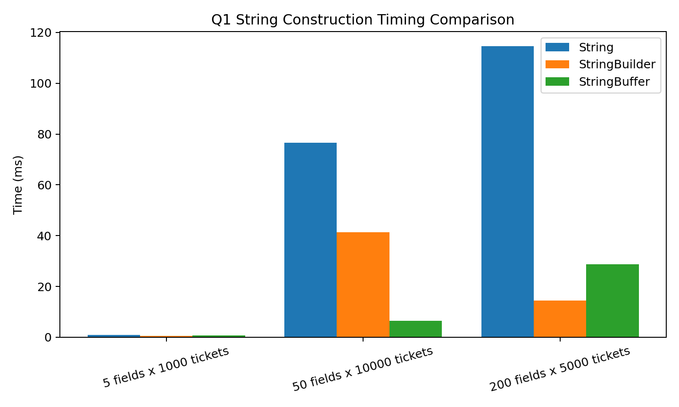
Analysis: Repeated String concatenation can create and copy immutable String values. StringBuilder uses a mutable buffer and is normally preferred for thread-confined construction; StringBuffer provides synchronized methods.

Q2 – ArrayList, LinkedList and ArrayDeque
Objective: Compare common collection operations across different sizes.
Size | ArrayList addEnd | LinkedList addEnd | ArrayList getMiddle | LinkedList getMiddle | ArrayDeque frontOps
1000 | 0.088 | 0.087 | 0.135 | 0.781 | 0.219
10000 | 0.41 | 0.337 | 0.6 | 6.682 | 0.471
100000 | 1.828 | 0.789 | 0.605 | 66.705 | 1.126
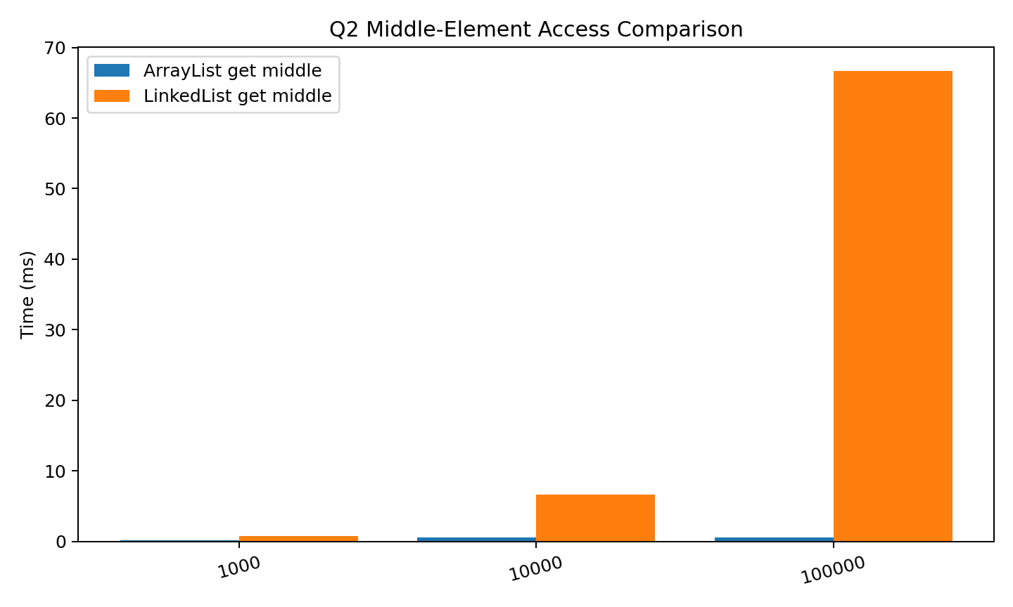
Analysis: ArrayList provides O(1) indexed access and amortized O(1) append. LinkedList indexed access is O(n). ArrayDeque provides amortized O(1) operations at both ends and does not support indexed access.

Q4 – HashMap, TreeMap and LinkedHashMap
Objective: Compare lookup performance and ordering behavior.
Size | HashMap lookup | TreeMap lookup | LinkedHashMap lookup | TreeMap report
1000 | 38.535 | 33.975 | 28.444 | 0.116
10000 | 44.63 | 37.577 | 39.641 | 0.421
100000 | 94.064 | 38.524 | 32.004 | 0.53
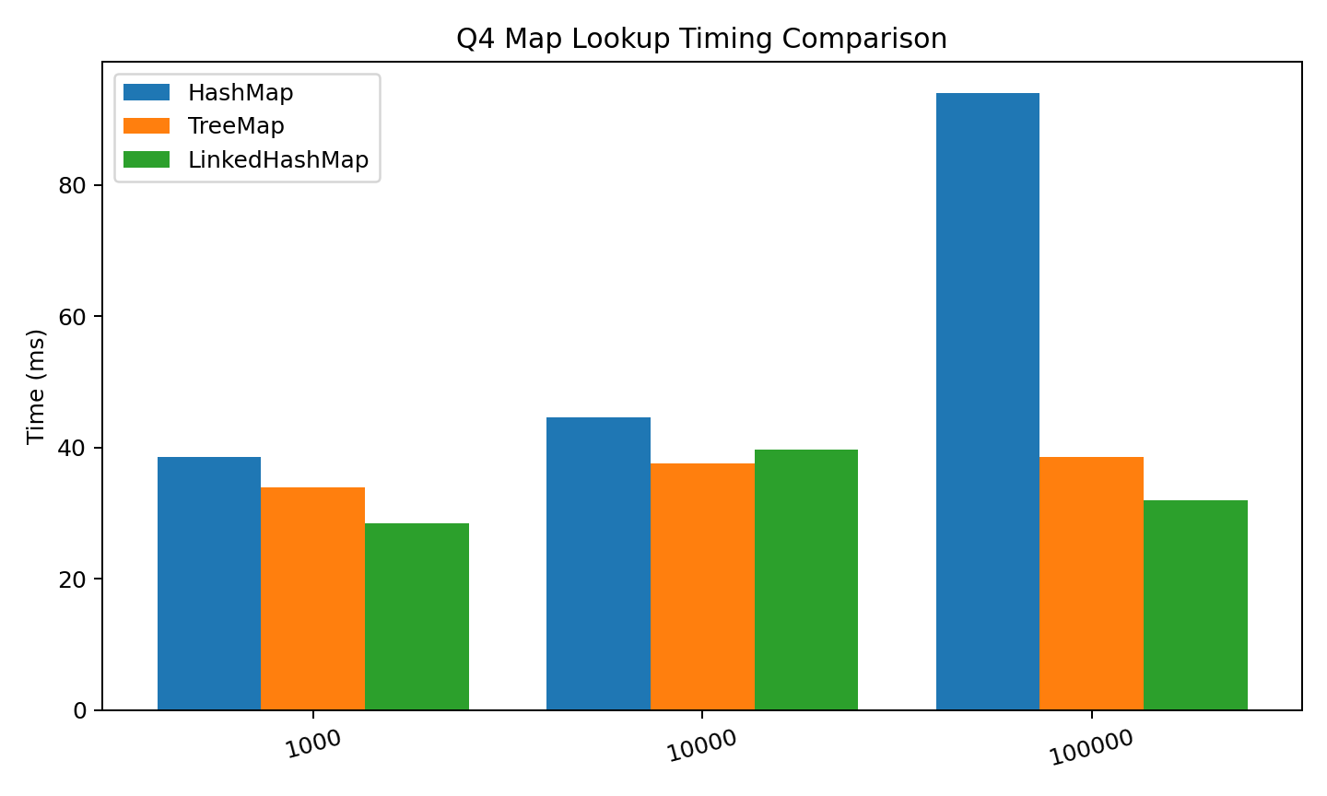
Analysis: HashMap offers expected O(1) average lookup, TreeMap maintains sorted keys with O(log n) basic operations, and LinkedHashMap preserves insertion order with HashMap-like average lookup behavior.

Q7 – Design Challenge
Objective: Diagnose one limitation, redesign it, and validate the improvement.
Fields | Original (ms) | Redesigned (ms) | Improvement (%)
100 | 0.415 | 0.062 | 85.04
1000 | 2.469 | 0.11 | 95.54
5000 | 48.472 | 0.363 | 99.25
10000 | 44.1 | 0.219 | 99.5
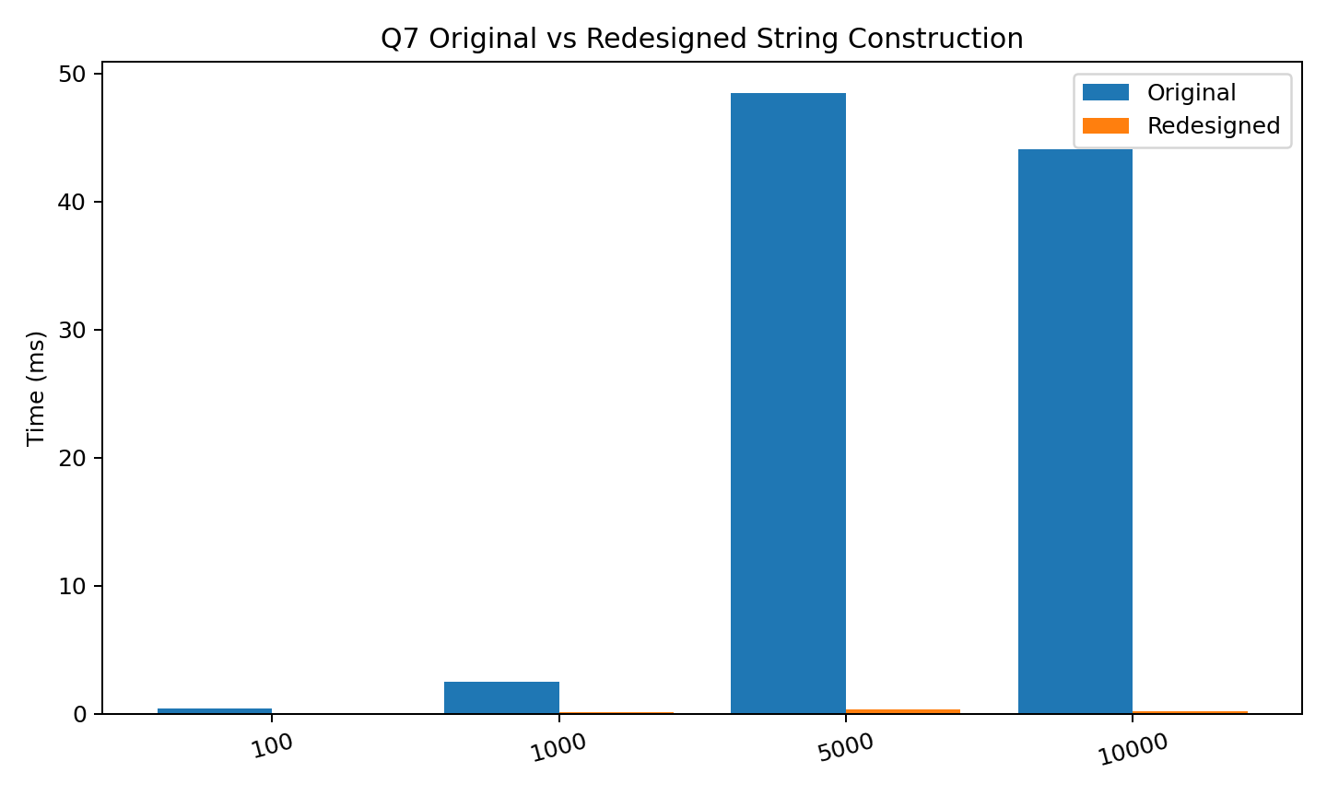
Analysis: The selected limitation is repeated immutable String construction. The redesigned solution uses StringBuilder to reduce intermediate String creation and character copying.

Q3 – HashSet equals/hashCode Contract
Observed results: Without hashCode override: 2. Correct hashCode test result: 3. Complete-the-Code output: Unique students: 2.
HashSet uses hashCode() to select a bucket and equals() to distinguish matching elements. Equal objects must have equal hash codes. The corrected Student class follows the contract.
Files: HashSetExperiment.java, Attendance.java, input.txt and output_q3.png.

Q5 – Generic Leaderboard
Observed output: [Eagles(9,6), Bisons(9,4), Panthers(9,4), Cobras(6,1)]
Ranking uses points descending, goal difference descending, and name ascending. Bisons is above Panthers because their points and goal difference are equal and the name tie-breaker is applied.
Files: LeaderboardDemo.java, input.txt and output_q5.png.

Q6 – PriorityQueue Triage
Observed treatment order: Meena(S1) Kumar(S1) Lata(S2) Ravi(S3) John(S3) Asha(S5)
Severity 1 has the highest priority, and the arrival counter preserves FIFO order for equal severity. A plain FIFO Queue cannot directly express this priority rule.
Files: Triage.java, input.txt and output_q6.png.

2. Raw Experimental Data
The CSV files in Raw_Experimental_Data/ contain the measurements/results used for the report tables and graphs.

3. Tables and Graphs
The PNG files in Tables_and_Graphs/ contain the analysis graphs for Q1, Q2, Q4 and Q7.

4. Complete-the-Code Evidence
The completed programs are included in the corresponding Q folders. Their output screenshots are stored under each task's screenshots folder.

5. Conclusion
The experiments show that Java collection and string implementation choices should match the required operation pattern. The assignment follows the required workflow of Predict → Design → Implement → Measure → Analyse → Evaluate → Diagnose → Redesign → Validate.

